TASK 4

Rock-Paper-Scissors Game

User Input: Prompt the user to choose rock, paper, or scissors.

Computer Selection: Generate a random choice (rock, paper, or scissors) for the computer.

Game Logic: Determine the winner based on the user's choice and the computer's choice.

Rock beats scissors, scissors beat paper, and paper beats rock.

Display Result: Show the user's choice and the computer's choice.

Display the result, whether the user wins, loses, or it's a tie.

Score Tracking (Optional): Keep track of the user's and computer's scores for multiple rounds.

Play Again: Ask the user if they want to play another round.

User Interface: Design a user-friendly interface with clear instructions and feedback.

CODE:

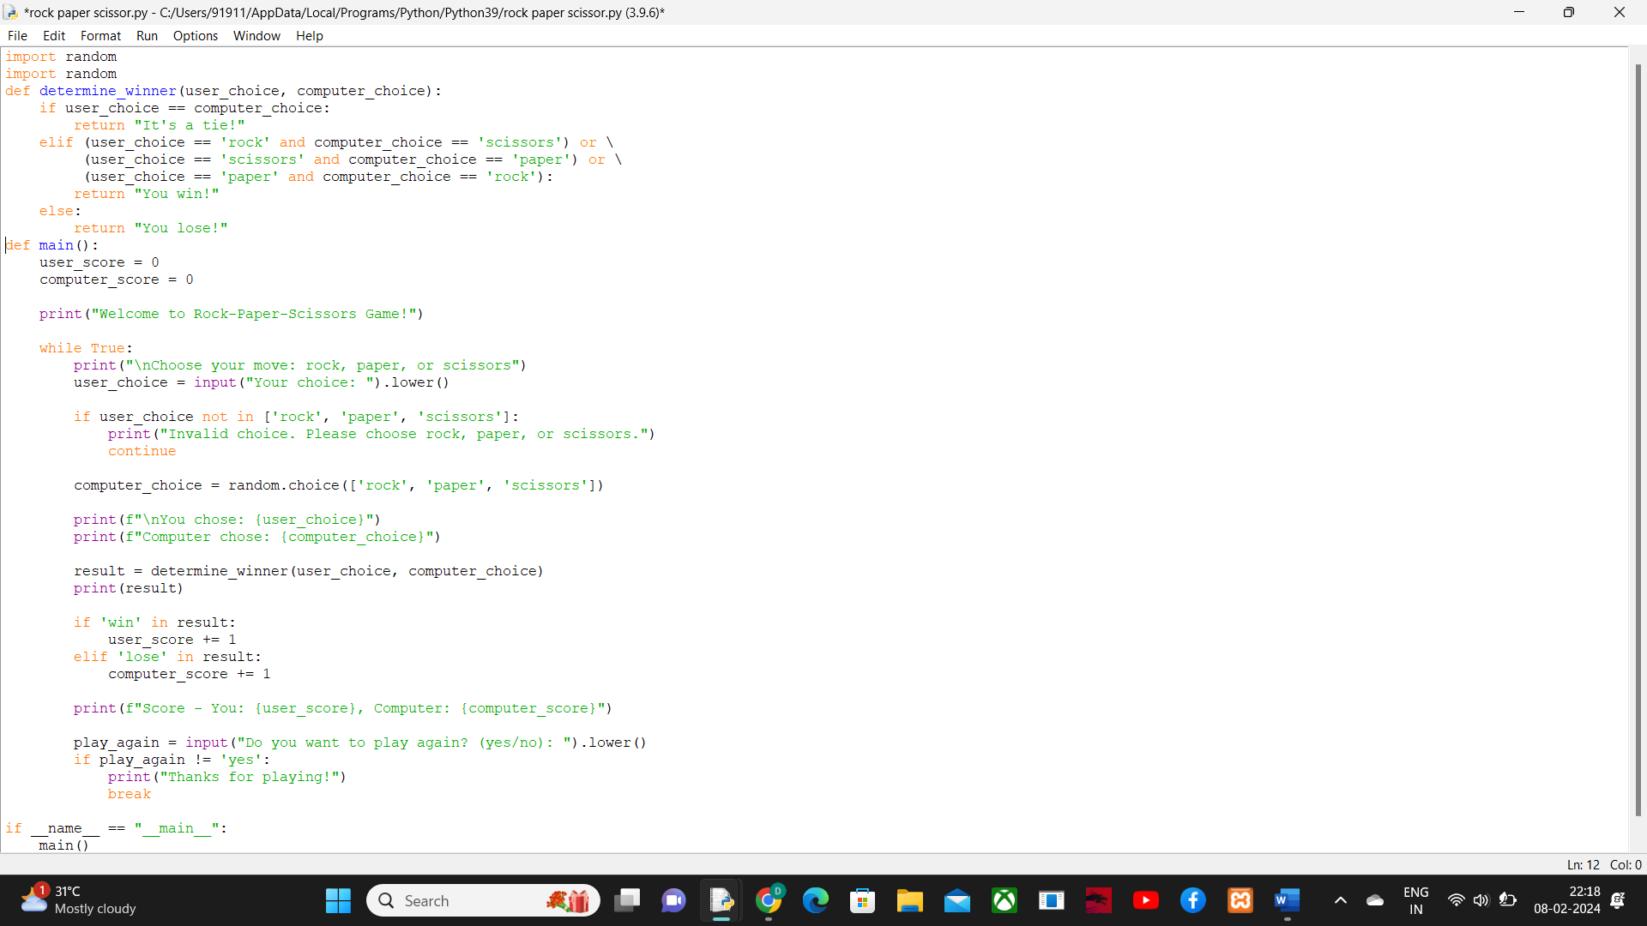

OUTPUT:

